COVER, REVISION HISTORY AND APPROVAL PAGE
Revision No. | Brief Description of Change | Effectivity Date
0 | Origination

 | Name | Signature
Originated/ Revised by: | Virtron K. Bumal-o  Project Manager | See DCN

Reviewed by: | Sherman A. Semanero  Project Manager | See DCN
 | Marjorie Laranang Olivete  Admin Director/ QMR | See DCN

Approved by: | Fernando C. Laranang  President/CEO | See DCN
Date Approved

Distribution List

President/CEO | Project Manager’s (2) | Document Controller
QMR/BOD’s | Admin (Common Copy)

- PURPOSE AND SCOPE

To develop procedures for CHB (Concrete Hollow Block) wall installation and cement plastering, ensuring proper coordination, quality control, inspection, documentation, and construction execution throughout the process, resulting in a durable, stable, and aesthetically pleasing wall structure.

- REFERENCE DOCUMENTS

FCLDC QAQC Manual
Plans and Specifications
Contract Documents

- DEFINITIONS

3.1 Definitions

Service agreement – Contract Between the General contractor stating the date the sub-contractor can begin work subject to the conditions stated on the agreement.

Plans and Specifications - a key part of the process of constructing a project. These documents are means of communicating between parties, and of ensuring that the appropriate designs, materials and construction techniques are used.

Bar Chart/S-Curve – a diagram showing the series of activities against timeliness until completion of the scope of works

FCLDC-Specific Project Quality Management Plan (FCLDC-SPQMP) – a document that details the description of quality control systems that include staff roles and relationship, procedures and any other resources that relate to producing high quality work output.

Purchasing and Logistic Officer- the department responsible for the purchasing of materials and equipment needed for the project.

- GENERAL REQUIREMENTS

4.1 Equipment, Materials and Documents

    - Service agreement, plans and specifications
    - Certificate (NC2)
    - Laser guided plumb tools, 1.5m – 2.0m spirit level
    - Computers and office supplies

  - Safety and Environmental

    - Each worksite and employee function are thoroughly assessed in a manner that ensures safety for themselves, property owners and representatives, the general public, and the environment.

- PROCEDURE / INSTRUCTIONS

Procedure Outline

5.1 Service agreement and Orientation

5.2 Mobilization and installation of temporary facilities and Safety requirements

5.3 Project scheduling and Material take-off

5.4 Execution and Monitoring

5.5 Inspection and Billing Report

Procedure Details

Responsible Person | Activities | Interface Document/Person
 | 5.1 Service agreement and Orientation
Finance  Project Mananger | - Signing and Issuance of service agreement | Gencon and sub-con
QA/QC Engineer  Safety Officer  HR officer | - Conduct orientation on safety protocols, site rules and work hazards on the specific work.  - Orient the workers on the importance of quality control and assurance during the execution of CHB wall installation and cement plastering. | Contractor  NTP
 | - Mobilization and installation of temporary facilities and safety requirements
Technical Team | - Provide space for the temporary facilities of sub-contractors including designated C.R and washing area. | Sub-contractor
 | 5.3 Project Scheduling and Material take-off
Technical Team | - Provide specific schedule for the subcontractor’s guide. | Bar Chart/S-Curve
 | 5.4 Execution and Monitoring
Site Engineer  Foreman  Subcontractor  Subcontractor  Site Engineer  Subcontractor  Subcontractor  Subcontractor  Site Engineer  Foreman  Subcontractor  Site Engineer  Subcontractor  Subcontractor | 5.4.1 CHB wall Installation  - Site Engineer to issue approved plans and coordinate with the foreman to layout the area to be laid out with CHB wall using laser guided instrument with chalk markings.  - Throughout the layout, the foreman must establish and take notes of the difference against the existing structure of that of the architectural plans.  - After establishing the lines of proposed walls, the engineer must verify the accuracy of the markings and references such as the plumbness (Hulog), angles (squala) and measures as reflected on the approved plans. Discuss corrections that might affect the architectural layout due to existing structures misalignment, inform and resolve with the Project manager of any significant errors.  - Use/install 1-1/2” square tube vertical guide, flash on the exterior markings of CHB blocks, vertically plumb and locked on both end of the wall as horizontal guide for laying CHB blocks.  - Use “tansi” or nylon wire as guide for horizontal alignment, tied on the fixed vertical plumb 1-1/2” square tube on both ends. Use customized base jack to lock the bottom and upper part of the square tube, alternately we can use laser guide for chb laying  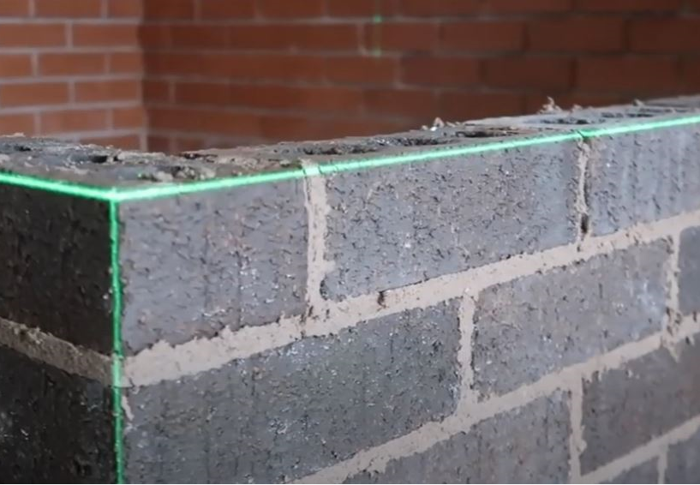  Laser guide  Laying of chb wall using laser guide  - After determining the boundaries of the walls with chalk, start by drilling 3” deep holes on the center for vertical rebars installation in accordance with the spacing provided on the specification. Use structural epoxy bonding between the rebar and the concrete.  - Lay mortar bed. Make sure that the ratio for cement and sand for CHB mortar is 1:6 for 300 psi and below and 1:5 for 400 psi to 600 psi, the thickness of the mortar bed is between 2.5 cm and 4 cm.  - Lay CHB walls on the mortar bed, make sure that the blocks are aligned vertically and horizontally using the established 1-1/2” square tube guide.  - Upon reaching 4 level of CHB blocks approximately 1m height, the mason must request inspection from site engineer to verify the plumbness and allignment of the work done. The engineers must always monitor the progress of work and ensure that instructions are being sustained. Use 1.5m to 2.0m length bar level or leveling laser tools to double check the quality of the work. Take notes of all inspection done for the day using the Masonry Work checklist form.  - Carefully remove the 1-1/2” square tube vertical guide After completion of work and remove any mortar laitance on the surface of the wall.  5.4.2 Plastering works  5.4.2.1 Preparation of Surface for Plastering  - Keep all the mortar joints of wall rough, to give a good bonding to hold plaster.  - If RCW is to be plastered Roughen the entire surface by punching/chipping with conc. Nails.  - Clean all the joints and surfaces of the wall with a wire brush, there should be no oil or grease etc. left on wall surface.  - If there exist any cavities or holes on the surface, then fill it in advance with appropriate material.  - Wash the mortar joints and entire wall to be plastered, and keep it wet for at least 1 hours before applying cement plaster.  - For concrete stiffiner columns and beams, apply plaster-crete by buildrite or equivalent product to the surface intended to be plastered, reffer to product application procedure. Plastering of surface more than 1” thick need to apply a base coat of atleast ½” thk “rebukada”. Mix the mortar with - sika cembond BA by Sika Phils. allow to dry 24 hours before plastering  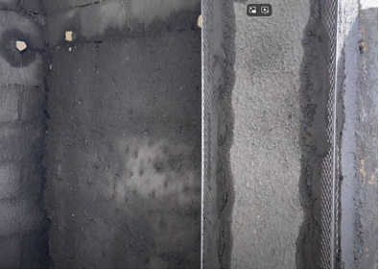  ½” thk cement mortar  w/ cembond “Rebukada”  G.I. corner fixing and  Angle bead fixing  Use as alternative if plastering is morethan 1” thick.  Basecoat with sika cembond BA  - If the projection on the wall surface is more than 12 mm, then knock it off, to obtain a uniform surface of wall. This will reduce the consumption of plaster  5.4.2.2 Ground preparation  For tropical heat area -Use Portland – pozzolana cement (PPC)  - To get uniform thickness of plastering throughout the wall surface, first fix dots on the wall. A dot means patch of plaster of size 25 mm * 25 mm and having thickness of about 10 mm.  - Dots are fixed on the wall first horizontally and then vertically at about 2 meters covering the entire wall surface.  - Check the verticality of dots, one over the other, by means of laser guided tools.  - After fixing dots, the vertical strips of plaster, known as screeds, are formed in between the dots. These screeds serve as the gauges for maintaining even thickness of plastering being applied.  Source: https://www.youtube.com/watch?v=18YHTRjAFHQ  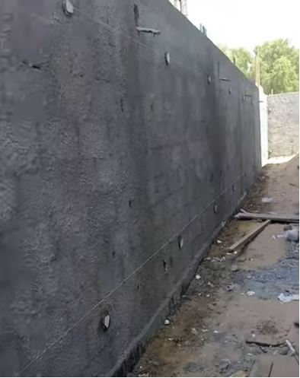  1”x1” fixed dots  Nylon guide  Installed of 1” x 1” fix dots  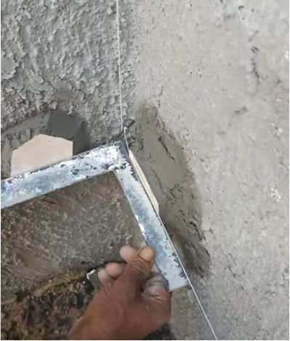  1mm nylon guide  Fixed dot  90 deg angle bar tool  Laying 90 degrees wall angle  5.4.2.3 Applying Under Coat or Base Coat  - In case of brick masonry, the thickness of first coat plaster is in general 12 mm and in case of concrete masonry this thickness varies from 9 to 15 mm.  - The ratio of cement and sand for first coat plaster varies from 1:3 to 1:6.  - Apply the first coat of plaster between the spaces formed by the screeds on the wall surface. This is done by means of trowel.  - Level the surface by means of flat wooden floats and wooden or aluminum straight edges.  - After leveling, left the first coat to set but not to dry and then roughen it with a scratching tool to form a key to the second coat of plaster.  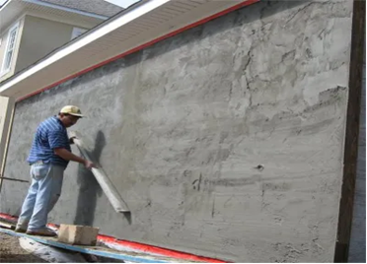  Base coat  12mm to 15mm thk  Straight edge bar  Leveling of surface using aluminum straight edges  5.4.2.4 Applying Finishing Coat  - The thickness of second coat or finishing coat may vary between 2 to 3 mm.  - The ratio of cement and sand for second coat plaster varies from 1:4 to 1:6.  - Before applying the second coat, damp the first coat evenly.  - Apply the finishing coat with wooden floats to a true even surface and using a steel trowel, give it a finishing touch.  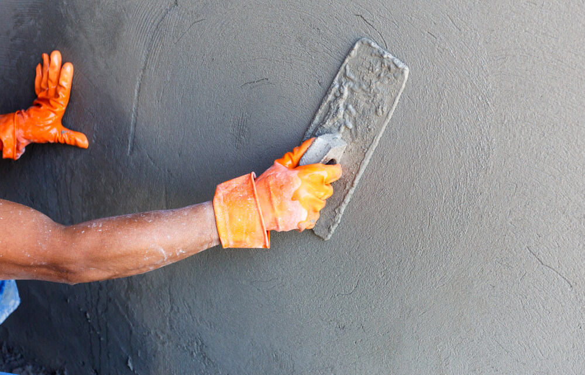  Steel trowel  Finish plaster  Finishing coat using steel trowel  - As far as possible, the finishing coat should be applied starting from top towards bottom and completed in one operation to eliminate joining marks  - During the process of plastering works the site engineer must always double check the plumbness and evenness of the surface using the 1.5m to 2.0m bar leveling, record all finding using the masonry checklist form.  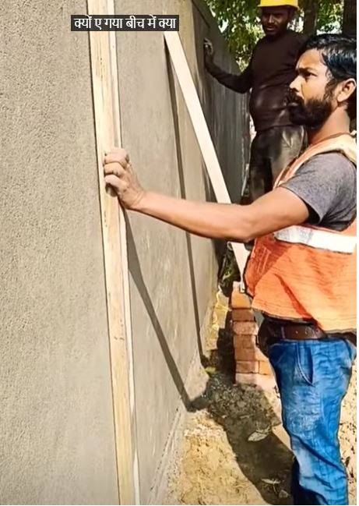  Straight edge bar  Checking plaster plumbness  5.4.2.5 Curing of Plastering works  - After completion of the plastering work, it is kept wet by sprinkling water for at least 7 days to develop strength and hardness.  - Use of gunny bags or other materials is used to keep the plastering works wet in external works.  - Improper curing may lead to cracks formation or efflorescence in plaster work.  Note: expose concrete columns and walls need not to be plastered, use rendering product such as boysen 202 to even the surface. In case the solid concrete needed to be plastered due to misalignment, use plaster crete product by buildrite or equivalent. | Approved plans  Masonry checklist form
Site Engineer  Subcontractor | 5.5 Inspection and Biling Report  - After 7 days, the Site Engineer and the subcontractor measure the work done for billing report, the site engineer double check the plumbness and evenness of the surface with reference to the daily masonry checklist form. This is to follow thru and to verify if corrections and comments on the work were properly address by the subcontractor.  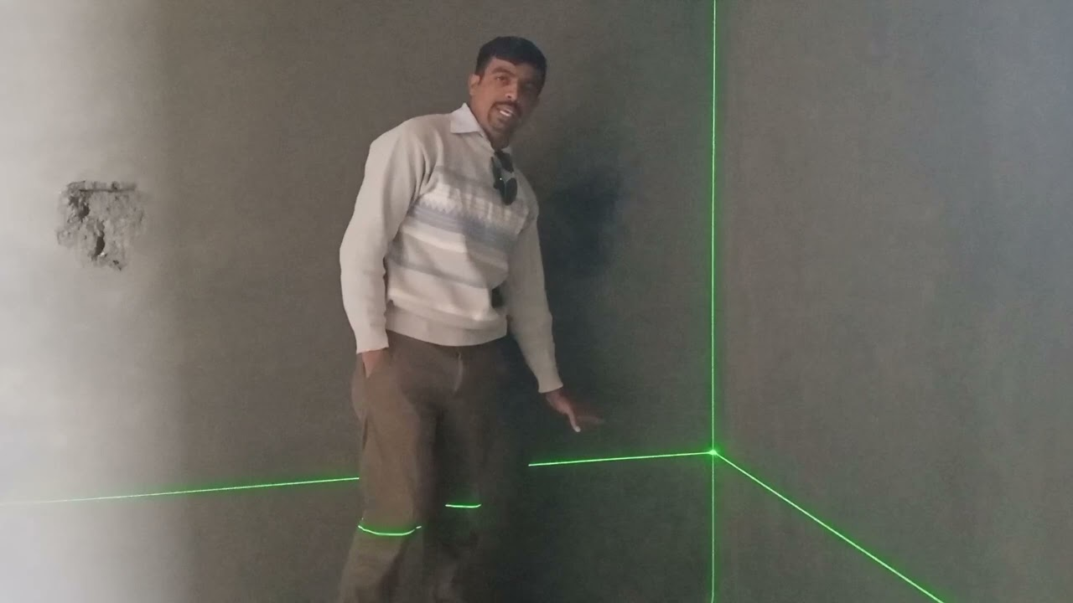  Laser guide  Checking of plumbness on corner by laser tools  - Inspected work with rectification will not be included in the billing until such repair is done by the subcontractor.  - Labor cost for all defects shall be at the expense of the subcontractor  - Incase the defect is not rectified; the admin will do the rectification and all labor cost incured therein will be deducted from the retention of the subcontractor.  Note: refer to the billing procedure stated on the service agreement | Service Agreement

7.0 APPENDICES

Service Agreement

PM-OPN-02-14Masonry Checklist form

Billing form

